2.3.2 Teachers use ICT enabled tools including online resources for effective
teaching and learning process.
DEPARTMENT OF MICROBIOLOGY

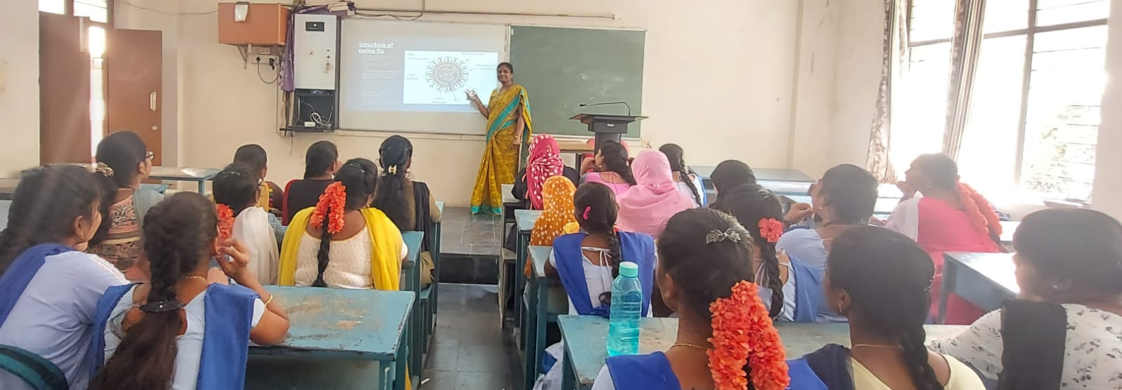

NAME : Dr.B.PRIYADARSINI
DESIGNATION : Lecturer in Microbiology
TOPIC : Viral Disease- Swine Flu
Cos/LEARNING OBJECTIVES : To learn about the Global, Historical
impact and transmission of this disease.
TEACHING METHODS ADOPTED : Participative learning [ PPT]
GROUP/SEMESTER : III BMC-V- SEM
APPLICATION : Knowledge and Awareness regarding
this disease.

